**Week 2_Mockito_HandsOn**

**Exercise 1: Mocking and Stubbing**

**ExternalApi.java**

package com.mockitDemo;

public interface ExternalApi {

String getData();

}

**MyService.java**

package com.mockitDemo;

public class MyService {

private ExternalApi externalApi;

public MyService(ExternalApi externalApi) {

this.externalApi = externalApi;

}

public String fetchData() {

return externalApi.getData();

}

}

**MyServiceTest.java**

package com.mockitDemo;

import static org.mockito.Mockito.*;

import static org.junit.jupiter.api.Assertions.*;

import org.junit.jupiter.api.Test;

import org.mockito.Mockito;

public class MyServiceTest {

@Test

public void testExternalApi() {

ExternalApi mockApi = Mockito.mock(ExternalApi.class);

when(mockApi.getData()).thenReturn("Mock Data");

MyService service = new MyService(mockApi);

String result = service.fetchData();

assertEquals("Mock Data", result);

}

}

**OUTPUT:**

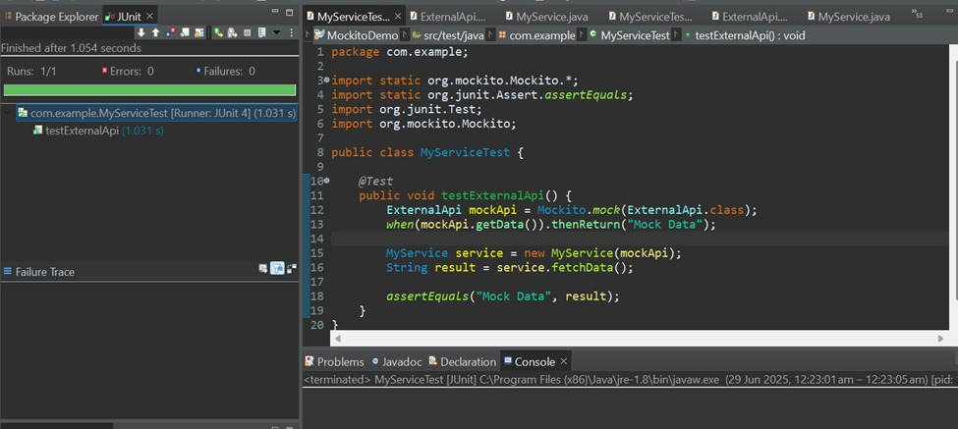

**Exercise 2: Verifying Interactions**

**MyServiceTest.java**

import static org.mockito.Mockito.*;

import static org.junit.jupiter.api.Assertions.*;

import org.junit.jupiter.api.Test;

import org.mockito.Mockito;

public class MyServiceTest {

@Test

public void testVerifyInteraction() {

ExternalApi mockApi = Mockito.mock(ExternalApi.class);

MyService service = new MyService(mockApi);

service.fetchData();

verify(mockApi).getData(); // verifies that getData() was called once

}

}

**OUTPUT:**

